Title: 🐭 Rat in a Maze
Subtitle: Backtracking Algorithm with Python & Streamlit Visualization
Group Members:
- Raghav Chauksey (Roll No: 38, Section: A6-B3)
- Kartik Gidwani (Roll No: 35, Section: A6-B3)
- Parth Pathak (Roll No: 47, Section: A6-B3)
- GitHub: 24gidwanik-ops/DaaEndSemProject

Objectives
Objectives of the Project:
- To design an interactive application that visualizes the rat solving a maze.
- To implement backtracking for pathfinding in a maze.
- To demonstrate algorithmic thinking through recursive problem-solving.
- To provide an easy-to-use GUI using Streamlit.

Introduction
Introduction:
- The “Rat in a Maze” problem is a classic AI and algorithm problem.
- The goal is to move from the start (top-left) to the end (bottom-right) of a maze.
- The project visualizes how the rat navigates through the maze using valid paths.
- Maze is represented as a 2D grid with:
  - 1 = open path
  - 0 = blocked path
Visual Tip: Include a small diagram showing a 4x4 maze with start and end.

Algorithm Used
Backtracking Algorithm:
- Start at (0,0) and recursively try moving in all directions (Down, Right, Up, Left).
- Mark path cells in a solution matrix.
- If a dead-end is reached, backtrack.
- Stop when reaching the bottom-right cell (n-1,n-1).
Why Backtracking?
- Explores all possible paths systematically.
- Ensures that if a path exists, it will be found.
Visual Tip: Include a small diagram showing the recursive steps.

Time Complexity
Time Complexity:
- Worst-case: O(4^(n^2)) (every cell tries 4 directions)
- Space Complexity: O(n^2) for the solution matrix
Explanation:
- n x n grid, each cell may attempt 4 moves recursively.
- Optimizations possible for larger mazes (not included in this basic version).

Tools & Technologies
- Python - core logic and algorithm implementation.
- Streamlit - interactive GUI for user input and visualization.
- Libraries Used:
  - numpy (optional for array handling)
  - streamlit

Features
Features of the Application:
- Dynamic maze input for any size (up to 10x10 for simplicity).
- User-friendly GUI to enter the maze and start solving.
- Solution displayed as a path matrix.
- Message displayed if no path exists.
- Real-time visualization of the rat’s path.

User Interface
UI Highlights:
- Streamlit input for maze size
- Interactive grid for maze input (1 for open, 0 for blocked)
- Solve Maze button
- Solution displayed below the maze input
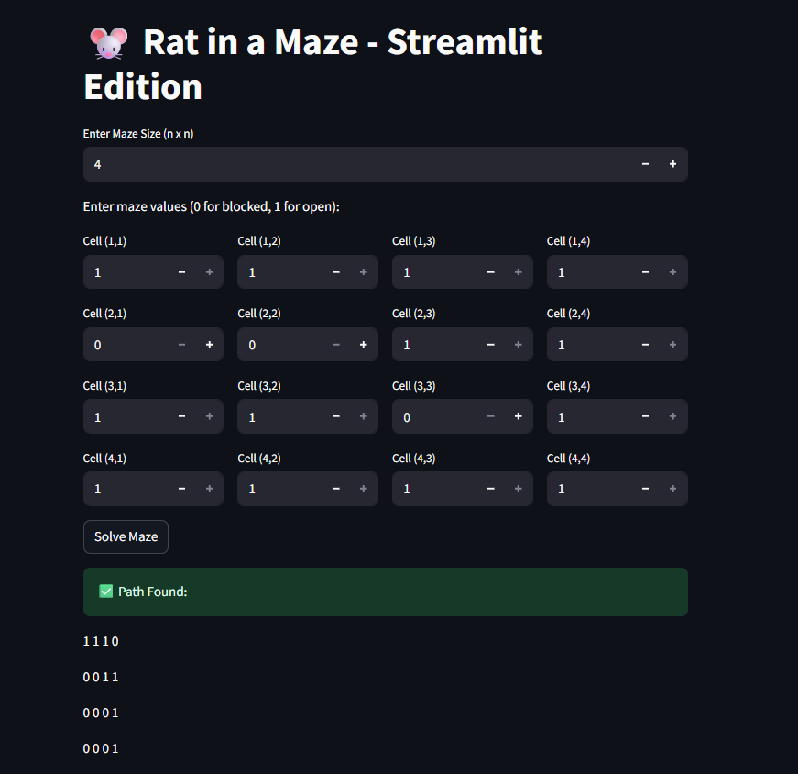

Slide 9: Demonstration
Demo:
- Enter a sample maze:
1 0 0 0
1 1 0 1
0 1 0 0
1 1 1 1

- Click Solve Maze
- Result: solution path highlighted or "No path found" displayed

Results
- Successfully finds the path from start to end if exists.
- Displays an error if no path is possible.
- Works for any valid n x n maze input.

Conclusion
Conclusion:
- Backtracking efficiently solves the Rat in a Maze problem.
- Streamlit makes visualization interactive and user-friendly.

References
- Python Documentation
- Streamlit Documentation
- “Rat in a Maze” problem resources
- GitHub repository link

